Understanding the role of management for natural variability in the context of inherent spatial and temporal heterogeneity in a tallgrass prairie plant community

McGlinn, Daniel^{1*}, Earls, Peter¹ and Palmer, Michael¹

Daniel McGlinn
¹ Department of Botany, Life Sciences East 117, Oklahoma State University, Stillwater, Oklahoma, 74078 USA; Email: danmcglinn@gmail.com
* correspondence author

Peter Earls
Email: earlsp@okstate.edu

Michael Palmer
Email: mike.palmer@okstate.edu

Running head:
Abstract
Introduction
Natural variability concepts of land management, which promote spatial and temporal variability, are increasingly utilized in restoration ecology (Palmer et al. 1997). Underling these concepts are two premises: 1) that historical conditions and processes can provide guidance for management, and 2) that spatial and temporal variability generated by disturbance are vital components of nearly all ecosystems (Landres et al. 1999). Managing for historical conditions is thought to benefit species that have evolved in that system and to minimize human alternations (Swanson et al. 1994). Spatial and temporal variability in management is thought to maintain biological diversity (MacArther 1965, Petraitis et al. 1989). Although these concepts are grounded in ecological theory, Palmer et al. (1997) notes, the importance of managing for natural variability are rarely examined experimentally.
The application of natural variability concepts is relevant to the conservation and restoration of the North American tallgrass prairie ecosystem. In this ecosystem fire and grazing were important components of disturbance regime in pre-Columbian North America (Anderson 1990) and still are today (Daubenmire 1968, Abrams et al. 1986, Collins 1992). Although historically the region was grazed by bison (Bos bison L.) and was burned in a variety of seasons, presently much of the remaining tallgrass prairie ecosystem is managed for cattle with annual spring burns (Fuhlendorf and Engle 2001) . The purpose of annual spring burning in is to maximize yields of palatable C4-grasses (Towne and Owensby 1984). Howe (1994) also noted that many restoration efforts on prairie remnants promote production of C4-grasses with spring season burning and a lack of grazing. These management practices may be a threat to the ecosystem’s biodiversity by only benefiting one competitively superior plant-functional group and by homogenizing an entire region’s disturbance regime (Howe 1994, Fuhlendorf and Engle 2001, Nekola and White 2002).
In an effort to restore natural variability to grazing systems, Fuhlendorf and Engle (2001, 2004) suggested the interaction between fire and grazing could be used in a more variable manner in space and time to create a shifting mosaic in contrast to the traditional homogenous application of these management tools. They argued that a mosaic of burned and unburned patches more closely approximates the historical variability that would have existed on the landscape and will result in higher biodiversity then traditional homogenous management practices (annual spring burning). This hypothesis is guiding the management of the Tallgrass Prairie Preserve (TGPP), the largest preserved tallgrass prairie in the world (Hamilton 1996, 2007).
The scale of the TGPP (15,700 ha) coupled with the spatial and temporal variability of the large-scale provides both important opportunities and challenges for experimentally evaluating aspects of the natural variability hypothesis. One of the opportunities that the TGPP offers is a chance to carry out an observational study that investigates the relative importance of management in a tallgrass prairie ecosystem that is presumably in somewhat of a more pre-Columbian (‘natural’) state given its intact native vegetation, the presence of free ranging bison, and the non-fixed burning regime. This opportunity is valuable because the majority of our knowledge on tallgrass prairie ecology either originates from relatively small scale experiments (e.g., Hulbert 1988) or from strictly controlled watershed treatments (e.g., Konza prairie LTER studies). Controlled studies are extremely valuable in elucidating ecological mechanisms that underlay a system, but they are less useful in providing the ability to examine multiple driving factors of community change within a broader ecological context. This can be better achieved by an observational study if properly designed (Halle 2007, Hobbs et al. 2007, Weiher 2007).
With these opportunities in mind, the purpose of this study was to investigate the variation in plant species richness and composition in space and time at the TGPP, and to detect the relative importance of management using prescribed burning and grazing by bison and/or cattle. Our goal was not to directly test whether or not variable management regimes are effective tools for meeting conservation targets, but rather to examine the relative influence that management has on the plant community when the management is guided by the natural variability hypothesis. As noted above a randomized block design of burning and grazing treatments is not easily implemented on the preserve, and therefore our study is observational in nature. Differences due to management within sites are likely to be strongly confounded by year-to-year variation in climate (Anderson 1982, Gibson and Hulbert 1987, Adler and Levine 2007) and between sites by variation in soil (Critchley et al. 2002) and topography (Abrams and Hulbert 1987, Briggs and Knapp 1995). However, these confounding variables can be used as covariables in multiple regression and partial canonical correspondence analysis (pCCA; Borcard et al. 1992) so that the amount of variation only explained by management can be quantified relative to other explanatory variables.
Using a mixture of explanatory modeling and ordination techniques we addressed three related questions. Is there directional change in species richness and species composition through time? What are the most important environmental variables for explaining plant richness and composition? If space and time are factored out does disturbance significantly correlate with richness or composition and in what way?
Methods
Study Site:
The TGPP is a 15,700 ha nature preserve located between 36.73° and 36.90° N latitude, and 96.32° and 96.49° W longitude, in Osage County, Oklahoma and owned by The Nature Conservancy (TNC). Over the course of the 11 year study period (1998-2008), total annual rainfall varied from 490 to 1250 mm. The preserve is situated at the southern extent of the Flint Hills region. The elevation of the preserve ranges from 253 to 366 m, and the underlying bedrock of the region is characterized by soils deriving from Permian sediment (Oviatt 1998). Due to long-term erosion, the surface layers of soil are thin and young; limestone and sandstone are frequently exposed at the surface, sometimes within close proximity of each other. Because of this rockiness the Flint Hills region, including the Tallgrass Prairie Preserve, has remained unplowed and has been instead utilized primarily as rangeland for cattle. Prior to the acquisition of the preserve by TNC in 1989, the majority of the site was managed for cow-calf and yearling cattle production with a 4- to 5-year rotation of prescribed burning and aerial application of broadleaf herbicides (1950-1989) (Hamilton 2007).
Approximately 90 % of the TGPP consists of grasslands. The majority of the grasslands are composed of tallgrass prairie habitats dominated by Andropogon gerardii, Sorghastrum nutans, Sporobolus compositus, Panicum virgatum, and Schizachyrium scoparium. Shortgrass prairie habitat occurs to a lesser extent on more xeric sites and is dominated by Bouteloua spp. Despite the application of herbicide earlier in the century the flora of the preserve appears relatively intact with a total of 763 species of vascular plants (to date) of which 12.1% are exotic (Palmer 2007).
Management:
The management at the TGPP was variable in space and time. In 1993, 300 bison were introduced year-round onto a 1,960 ha portion of the preserve (Hamilton 1996, 2007). As the bison herd increased in size, the area allotted to the herd was increased eight times to an area of 8,517 ha by 2007 (Fig. 1, 54% of preserve area). Initial bison stocking rates were increased in 1999 to 2.1 animal-unit months ha⁻¹ (see Hamilton 2007 for additional details). Within the bison unit animals were allowed to range freely and their movement was not obstructed by internal fences. Watersheds within the bison unit were considered randomly for burning only if they met the minimum fuel criteria of 900 kg ha⁻¹ of fine fuels. Within a given year, the season of burn of the bison unit was split as follows: 40 % dormant spring (March - April), 20 % late growing season (August - September), and 40 % dormant winter (October - December). The remainder of the preserve was seasonally grazed by cattle and typically burned more frequently in the dormant spring season, but some of the cattle pastures were utilized for smaller scale (2,350 ha) patch-burn experiments in which only one-third of a given management unit was burned annually (Hamilton 2007). Stocking within the cattle pastures included both intensive-early stocking and season-long stocking, which contrasted with the year-round stocking in the bison unit.
Data collection:
Because of the temporally variable and spatially aggregated nature of the management, we opted to annually re-sample a semi-random, spatially stratified set of twenty square 100 m² plots located at the intersections of the 1-km UTM grid (Fig. 1.). The only criteria that we imposed on the selection of our plots was that they contain less than 20 % of woody cover, standing water, or exposed rock. A semi-unbiased spatial stratification of samples is an ideal sampling method for ensuring that samples are representation of the broader variation in grassland communities across the preserve (Palmer 1995). Also an assumption of spatial independence is justifiable, with our design, given that the minimum distance between any two samples (1000 m) is almost two orders of magnitude larger than the maximum distance captured within a given sample (≈14.14 m). We opted to annually resample our sites in order to observe the vegetation at a given site in multiple management states (e.g., one year post burn, bison vs. cattle grazed), and to provide information on inherent year-to-year variation. We resampled our plots every June from 1998 to 2008 and recorded the percent cover of all vascular plant species at the 100 m² scale.
Each year we combined 15 cm soil cores collected at each corner of the quadrat and sent these to Brookside Labs (New Knoxville, Ohio) to be analyzed for soil cations, pH, and other variables. We recorded topographic data on slope and aspect in the field. For analyses, aspect was converted in a measurement of northness [northness = cos(aspect)] (Roberts 1986). We did not consider a corresponding index of eastness because of difficulties in ecological interpretation and exploratory results indicated it was unimportant (not shown).
Climatic variation was quantified with total monthly precipitation data that was downloaded from the Oklahaoma Mesonet Foraker site (36.840530° N, -96.427770° W; 330 m) which is located on the preserve (McPherson et al. 2007). We calculated total precipitation for three arbitrarily defined season variables (four months each): June through September (summer), October through January (winter), and February through May (spring).
We derived management variables including years of bison grazing, years since last burn, and number of burns in the past five years from a GIS database that we developed based on TNC’s recorded burn and grazing history. We recognize that the number of burns in the past five years is negatively correlated with years since last burn (appendix A) and reflects somewhat of an arbitrary cutoff point (five years), but we chose to include this variable in our models despite these shortcomings because we wished to quantify the short term burn history of a site. If a site is burned frequently then years since burn does not convey any information on the history of the site. We chose to not include season of burn as an explanatory variable because 83% (67 out of 80) of the prescribed fires recorded on our study sites took place during the dormant season. It is important to note that all of these management variables are dynamic in time, meaning that that there were not fixed treatments.
Data analysis:
Our goal when modeling richness and species composition was to develop explanatory models and not predictive models, sensu Mac Nally (2000). Therefore, we were primarily concerned with comparing the explanatory strength of variables that were chosen a prori rather than developing the a single most accurate or necessarily most parsimonious model/s. We made this conscious decision for two related reasons. Firstly, there are two published analyses that utilized portions of our dataset which indicate in part which variables may yield the greatest explanatory power (Palmer et al. 2003, Brokaw 2004). Secondly, we believe that given the observational natural of this study many of our explanatory variables are likely to act as proxy variables, and therefore we wish to clarify our interpretations by only examining a relatively small set of all potential explanatory variables and models.
We utilized ordinary least squares (OLS), generalized least squares (GLS), and redundancy analysis (RDA) to dissect relationships between species richness and our various explanatory variables. GLS models were considered because they allow us the ability to incorporate correlational models for the residuals of the model. When examining specific explanatory models, we compared 10 isotropic correlational models (5 one parameter and 5 two parameter) for the residuals of each explanatory model (see appendix B for description of models). The model with the lowest AIC value was then chosen to estimate effect sizes and carry out conditional F-tests for each explanatory variable of interest. If a model with one less parameter had an AIC within 3 of the minimum, then visual examination of model fit was used to judge which was more the more appropriate model. The GLS models were fit with a restricted maximum likelihood algorithm which is the preferred method for generating unbiased estimates of variance in models that have a relatively large number of parameters (Diggle et al. 1994). The R package nlme version 3.1-90 was used to carry out all GLS model fitting and diagnostics (Pinheiro et al. 2008). The RDA was utilized to examine the correlation between the management variables and the richness of several functional groups visually using an RDA biplot. This analysis was conducted in CANOCO version 4.5 (ter Braak and Šmilauer 2002a).
We utilized variation partitioning (or commonality analysis) to estimate the unique and shared fractions of explained variation in three factors (or classes of variables): sites, years, and management on richness (Legendre and Legendre 1998, Peres-Neto et al. 2006). Sites and years were quantified simply as dummy variables and the management factor was composed of the three management variables described above. We carried out partitioning with OLS as well as with GLS multiple regression. For each fraction of the OLS analysis we report both the coefficient of determination and its adjustment for number of variables, 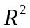 and 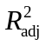 respectively. For the GLS fractions we calculated a generalized formulation of the coefficient of determination, 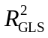, that is appropriate for GLS models (Nagelkerke 1991). For the variation partitioning the correlation structure of all models was assumed to be first-order autoregressive so that comparisons between fractions could be more easily interpreted.
To examine the importance of specific explanatory variables (i.e. not the dummy variables) on species richness, we constructed three conditional models one for each type of variation we were interested in (site specific, year specific, and management specific). Each model was constructed with covariables to give the most conservative estimate of the variable of interest’s influence on richness.
In all the analyses we treated species richness as a continuous variable with normally distributed error. We recognized that in some modeling contexts it is more appropriate to consider richness as a Poisson distributed variable (rather than a normal one) (Candy 1997, Palmer and Hussain 1997). However, because the normal distribution provides a good approximation of a Poisson random variable when the mean is larger than approximately 20; we feel that our usage of normal errors (instead of Poisson) is justified given that richness was never below 48 in our samples. We also recognize that some authors consider richness to only be one facet of grassland biodiversity and that other diversity indices can yield more insight into the ecology of the system (Wilsey et al. 2005, Chalcraft et al. 2009). This may be potentially true, but in this study richness was so strongly correlated with all of the indices examined in Wilsey et al. (2005) that additional analyses on various diversity indices would have yielded little additional insight (See appendix C).
We utilized both indirect and direct ordination methods to examine changes in species composition. Prior to all ordinations, we square-root transformed all species cover data, down-weighted rare species, and log-transformed the soil variables (Palmer 1990). Detrended Correspondence Analysis (DCA; Hill and Gauch 1980) was used to visually inspect directional change in the plant composition through time for all three subsets of the data and to get an estimate of the amount of variation the species displayed across a hypothetical environmental gradient. Non-metric multidimensional scaling (NMS), another indirect ordination technique that in contrast to DCA does not assume the existence of a hypothetical environmental gradient, was used to confirm the general conclusions of the DCA.
For the analysis of species composition we also carried out variation partitioning but with partial canonical correspondence analysis (pCCA) (Borcard et al. 1992, Okland 1999). The factors used in the variation partitioning were as defined above for richness. We calculated Peres-Neto et al.’s (2006) formulation of the adjusted fraction of variation explained in CCA using a permutation approach (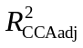). To our knowledge, correlational models for the residuals have not been theoretically developed within the direct ordination context and therefore these methods were not applied in our analysis of species composition. However, when testing the importance of dependent variables that accounted for the within-site variability in species composition we conducted a torodial shift Monte Carlo test on the reduced model (Legendre 1993, ter Braak and Šmilauer 2002b). This method of permutation maintains the observed order of the samples within a site while nullifying the temporal relationship of samples between sites. When the constraining variable was site specific, we carried out permutations that randomly shuffled samples only within their year of occurrence which agrees with our assumption of spatial independence between sites but not years. All randomization tests were conducted with 999 iterations to determine significance of all canonical axes for all partial CCA analyses under the reduced model. As in the analysis on richness, we constructed models to examine the importance of specific explanatory variables through estimates of variation explained and conditional F-tests. We preformed multivariate analyses with CANOCO version 4.5 and the R package vegan version 1.15-1 (ter Braak and Šmilauer 2002a, Oksanen et al. 2008, R Developmental Core Team 2008).
Results
Variance in species richness
The average species richness over the 11 year study was 76.24 (± 0.86). The within site variance (σ = 9.13) in richness was approximately equal the between plot variance (σ = 8.93). There was not strong directional changes in total richness (not shown ) or in the four functional groups through time (Fig. 2). Forbs were significantly more rich than all other functional groups. Variation partitioning based on the unbiased estimate of variance explained by OLS (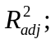Table 1), indicated that between site differences accounted for the majority of variability in richness (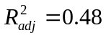), followed by year-to-year differences (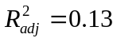). However, after the within-site temporal autocorrelation was considered (using a first-order auto-regressive term); the strength of plot identity relative to year identity was diminished quite a bit according to Nagelkerke’s (1991) generalized definition of the coefficient of determination. In both OLS and GLS based variation partitioning, the management class of variables accounted for a much smaller percentage of explained variance in richness (2-4%), but still contributed a significant amount of explained variation as judged by conditional (type III) F-tests at an alpha level of 0.05 (Table 2). The shared component of variation between management and site was larger than the influence of management alone, but the same was not true when comparing year and management after correcting for temporal autocorrelation in which case the shared component was effectively zero.
The most important variable for site to site differences was log Ca which was negatively correlated with richness (standardized coefficient [β] = -0.28) (Table 2). Topography did not seem to have a strong influence on richness as neither slope nor northness explained much variation in richness. The most important seasonal rainfall variable was summer rain which was negatively correlated with richness (β = -0.19), winter rain and spring rain appeared equally important and both were positively associated with richness (β = 0.15 and 0.14 respectively). The single most important management variable was years of bison which was positively associated with richness (β = 0.43). Both years since burn and number of burns in the past five years were negatively associated with richness but neither variable was found to explain significantly more variation in richness than due to chance.
Variance in species composition:
The DCA scatterplot indicated that there was non-directional change in species composition through time (Fig. 4). Furthermore, sites remained relatively separate from one another in ordination space which indicates that variation in species composition was greater between sites than within sites. There was not a strong difference in sample scores between sites that were bison versus cattle grazed along the first of second DCA axes. Furthermore, when samples switched from cattle to bison their trajectory through time did not substantially change. The results of the NMDS (not shown) corroborated these qualitative results.
Variation partitioning based upon CCA indicated that site effects explained the majority of the variation in species composition (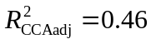, Fig. 5). Year and management effects on species composition were negligibly small after adjustment, but both were still found to be significant in randomization tests at the 0.05 level (Table 3). There was a somewhat large shared site and management fraction (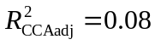) of explained variation. This suggests that the majority of management effects were site specific. The pCCAs that considered site specific explanatory variables after factoring out year and management effects indicated that log Ca was the most important site specific variable (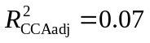; Table 3).

Although management explained only a very small proportion of the variation in species composition, we feel that for applied purposes it is still worth examining the management effects on particular species using a pCCA biplot (Fig. 6). The pCCA biplot displays only the 90 most abundant species (although all 307 species were included in the analysis) with respect to the three management variables after factoring out year and site effects as dummy variables. It appeared that both C3 and C4 grasses (open and filled black circles on biplot respectively) appeared to decrease in cover with increased years of bison grazing. The invasive species, Lespedeza cuneata (sericea lespedeza) was positively correlated with years of bison grazing. However, this species is a target for herbicide application by the TNC so care must be taken in interpretation of this result. Annual and ruderal species such as Chamaesyce nutans (eye bane), Plantago virginica (Virginia plantain), Ambrosia artemisiifolia (annual ragweed), and Andropogon virginicus (broomsedge bluestem) all were positively associated with the number of burns in the past five years.
Discussion
The purpose of our study was to examine the influence of a variable management regime on plant richness and composition relative to site-to-site and year-to-year variability. Our results suggested that the grasslands of the TGPP are not undergoing strong directional changes in richness or composition through time (i.e. they do not appear to be on a clear trajectory). Rather, samples appear to maintain their differences over time and respond somewhat idiosyncratically to management effects. This is not to say that we did not detect significant management effects on richness and composition independent of site and year effects, but simply that the management effects were relatively unimportant relative to these other two sources of variation.
Role and drivers of site-to-site variation
The bulk of the variation in richness and composition was due to differences between sites which we believe primarily reflects belowground differences between our samples. We found that Ca explained the predominant amount of site-to-site variability in both richness and composition (Fig. 3, Table 2). We interpret Ca’s importance to be due to its role as a proxy variable for many other soil properties which are generally indicative of limestone derived soils (following, Palmer et al. 2003, Brokaw 2004). Using the same 20 sites analyzed in this study (only for the year 2002), Brokaw (2004) found that out of a set of 12 different soil nutrients and total carbon that the two most important variables for explaining plant composition (using pCCA) were total C (C_{t}) and recalcitrant P (P_{r}). Both of these soil variables were positively correlated with Ca and when compared to two other soil cations (Fe and Zn) as well as slope, C_{t} and P_{r} did not explain a significantly different portion of variation in composition (i.e. they were redundant with the other variables). Brokaw (2004) also found that C_{t} was strongly positively correlated with the majority of soil nutrients and a general indicator (like Ca) of limestone parent materials which tend to be more productive (ref.). These findings suggest that the important role that Ca played in our study does not necessary contradict the body of work that suggests that below ground nutrients are the predominant drivers (not cations) of plant richness and composition in tallgrass prairie ecosystems (Turner et al. 1997, Burke et al. 1998, Baer et al. 2003, 2004).

Why was the relationship between Ca and richness negative? The positive relationship between Ca and soil nutrients (that Brokaw [2004] found in our samples) suggests one possible explanation. If soil high in Ca are the productive, nutrient rich soils then plant species at these sites may experience stronger competitive exclusion and therefore these sites have lower richness (Grime 1973, Tilman 1982). Partel’s (2002) species pool hypothesis offers an alternative hypothesis for the negative correlation between richness and Ca (Palmer et al. 2003). The species pool hypothesis postulates that negative correlations between richness and pH (or Ca given their tight correlation) will occur in regions in which habitats high in pH were evolutionarily scarce. Palmer et al. (2003) found that the data from the Tallgrass Prairie Preserve (including this study’s sites as well as many others) appeared to support Partel’s hypothesis in the grasslands but not in the woodlands.
Role and drivers of year-to-year variation
Year-to-year variation was a better explanatory variable of richness than composition. This indicates that changes in year-to-year composition were primarily by species that had a small percent cover estimate. Relative to site and management factors, the year factor explained almost equal amounts of variation in richness as site effects (21% compared to 25%) with 9 fewer parameters. With respect to species composition, year effects were more comparable with the small influence of management (both were < 1%).
Climatic variability is the most obvious driver of year-to-year variation (that is independent of management effects). In the tallgrass prairie plant community water is typically viewed as an important limiting resource, and it is generally positively associated with richness in grasslands (Cornwell and Grubb 2003, Adler and Levine 2007, Wilson 2007). In our study, richness was positively correlated with the winter and spring seasonal precipitation variables, but negatively correlated with the summer precipitation variable. Although all the season variables explained a significant amount of variance in richness, it appeared that the independent negative effect of the summer variable was largest with respect to richness (Table 2). Following Adler and Levine (2007), increased precipitation may act on richness directly by making the environment more benign and thus allowing more species to coexist. However, if this was the case then we should have found a strong positive or possibly no correlation of each and every season variable with richness (no a strong negative correlation as was the case fur summer rainfall). An alternative season specific hypothesis that may explain the negative relationship with summer rainfall, is that increased precipitation in the summer previous to sampling yields higher above ground cover of C4 grasses. This increased level of above ground productivity could act to both inhibit germination of annuals and biennials later at the beginning of the next growing season, as well as, increase asymmetric light competition due to increased litter (Grace 2001). The positive influence of spring and winter rains may also be explained by the critical role that rainfall plays in stimulating germination in the annuals and biennials during the dormant season. In this sense precipitation is viewed as a non-resource variable that indirectly influences richness by increasing above ground primary productivity the summer prior to sampling and by influencing germination of species rich plant groups.
Independent management effects
Despite the occurrence of a total of 80 prescribed fires and the usage of different grazers, our results indicated that management effects were relatively minor in comparison to inherent site and year heterogeneity. This result is in conflict with the dominant paradigm of tallgrass prairie ecology which asserts that management tools such as fire and grazing are the dominant drivers of diversity and composition in the plant community (Collins 1987, Gibson and Hulbert 1987, Anderson 1990) Although the importance of site and year effects is not a novel insight in this system, they are rarely observed to dominate the influence of management so strongly. There are several reasons that likely led to this result. Our samples cover a larger spatial extent than the majority of other tallgrass prairie studies given the large size of the TGPP. Additionally, due to the observational nature of our study we did not compare our samples to control sites that received no burning and/ or grazing although some of our sites went as long as 10 years without experiencing fire. And lastly, by utilizing site and year dummy variables we provided a conservative (but we believe more honest) estimate of the independent influence of management.
Although management in explained little variation overall, years of bison grazing had a strong positive relationship with richness (Table 2). The importance of this variable must be considered carefully though, because bison management units were managed differently than cattle management units. Specifically, the average fire return interval was set at approximately 3 years in the bison units which was generally longer than in cattle units and season of burn was more variable then in the cattle plots (Hamilton 2007). Also the bison units are grazed year round, while the cattle units are only seasonally grazed. Therefore, although we are fairly confident that the length of time a site has occurred within the bison unit is positively correlated with that site’s richness, we are less confident that this is due actually to the presence of bison in comparison to cattle.
It has been hypothesized that the presence of bison increases the richness of vascular plants because they selectively forage on graminoids rather than forbs (in contrast to cattle which behave more as generalists) (Coppedge et al. 1998b, Knapp et al. 1999). This dietary behavior is hypothesized to release the forbs from competitive exclusion from the dominant C4 grasses. The pRDA biplot (Fig. 4) on the richness of the plant functional groups indicated that all functional groups tended to increase in richness in the bison grazed sites except the C4 grasses. Although we did not record data on the total cover of each functional group, the pCCA biplot (Fig. 6) suggested that years of bison grazing was negatively correlated with the cover of the majority of C3 and C4 species. Both of these findings lend modest support to the hypothesis that bison may increase richness of tallgrass prairie by decreasing the cover of graminoids relative to sites that were grazed seasonally by cattle.
Towne et al. (2005) undertook a more controlled approach to investigating the effects of bison and cattle grazing on plant richness and composition at the Konza tallgrass prairie over a 10 year period in annually burned pastures. They also found that overall the differences between bison and cattle were slight but that bison grazed patches had a higher cover of some forb species and gained forb species through time at a more rapid rate. Towne et al.’s general conclusion that the differences reported between cattle and bison grazing in the literature may be predominately due to differences in management of the units and not due to inherent differences between these two grazers certainly may apply to our findings as well.
According to the pCCA biplot, years since last burn was most strongly correlated with changes in species composition (Fig. 6), but the other two management variables explained comparable amounts of variation (Table 3). Other studies have noted the strong positive relationship between cover of legumes and C4 grasses with frequency of dormant season burning (Hulbert 1988, Towne and Knapp 1996, Coppedge et al. 1998a, Peterson et al. 2007), although 84% of the burns in our samples occurred during the dormant season there was not a clear relationship between fire frequency and either of these functional groups (Fig 3, Fig. 6). We found anecdotal evidence that ruderal species were positively associated with the number of burns in the past five years (Fig. 6) which is to be expected given that these samples were likely to have higher grazing pressure due to their more nutritious regrowth (Coppedge and Shaw 1998, Fuhlendorf and Engle 2001).
Management implications:
The primary implication that our study is that the importance of the template or inherent site-to-site heterogeneity cannot be neglected when testing ecological theory, setting conservation goals, or evaluating restoration progress. Despite the experimental evidence that studies have provided on the strong role of management in our study system, these variables were not as important as variation due to soil or climate. Therefore we suggest that ecologists and managers keep an open mind to the potential drivers of their ecological systems and not simply the aspects that they can manipulate.
Another implication of our results is that conservation priorities and restoration targets should be viewed within the context of the important environmental gradients that shape community composition (White and Walker 1997, Nekola and White 2002). Our study site, the TGPP, occurs in the Flint Hills region of Oklahoma and Kansas where the largest amount of contiguous unplowed tallgrass prairie remains. Future preserve design in this region should strongly consider capturing as much of the limestone to sandstone gradient within the preserve as possible, in order to capture a larger degree of complementarily in plant species composition. The importance of observations studies:
It is important to recognize that even without control treatments that observation studies can provide vital information about the ecology of a system (Underwood et al. 2000, Legg and Nagy 2006, MacNeil 2008). In our study site, the appropriateness of a long-term observation study (rather than a manipulative one) was obvious given the temporally dynamic nature of the management at the preserve. We hope that our study encourages other ecologists and land managers to view monitoring long-term plots as a potentially valuable source of information despite a lack of clearly defined treatments and controls. This is not to say that experimental studies are not extremely useful and mandatory for uncovering driving mechanisms, but rather that we wish to encourage practitioners to consider utilizing both inductive and deductive modes of reasoning to understand the ecology of their systems and place their results into context.
Conclusions:
Inherent variation between sites and years related to below ground differences and precipitation respectively explained the predominant amount of variation in species richness. Management played a relatively small role in shaping richness after accounting for site and year effects; however, years of bison was strongly positively correlated with richness. Although, the importance of bison is likely to be primarily related to differences in management between the bison and cattle grazed sites rather than differences in the ecology of these grazers, we found modest evidence that bison were decreasing the cover of graminoids and therefore potentially increasing richness by releasing the forb species from asymmetric light competition. We also found that soil variation but not climate was influential in shaping species composition. Management effects were not strongly related to differences in species composition.
Acknowledgments
We thank Bob Hamilton, Jayne Salisbury, Kindy Chang, Sandy Earls, Sandy Stevens, Kerry Sublette, James Shaw, Sonia Jaiswal, Chris Sellers, Norman Elliott, Wade French, Suzanne McAlister, Eric Maichak, Ronald Tyrl, Steven Thompson, Reinhard Spiegelhauer, David Nemcock, Linda Gatti-Clark, Karol Ezell, Kevin Belt, Marissa Raglin, Thomas Wohlgemuth, Chris Hise, Dai-Jun Zhang, John Wilson, Jerry Husak, Larry Thiesen, Joshua Brokaw, Jerad Linneman, Ken Hobson, The Oklahoma State University College of Arts and Science, The Oklahoma Nature Conservancy, The Spatial and Environmental Information
Clearinghouse, The Philecology Trust, The Swiss Federal Institute for Forest, Snow and Landscape Research, and the Oklahoma Water Resources Research Institute for assistance at various stages of research at the Tallgrass Prairie Preserve.
References:
Abrams, M. D. and L. C. Hulbert. 1987. Effect of topographic position and fire on species composition in tallgrass prairie in northeast Kansas. American Midland Naturalist 117:442-445.
Abrams, M. D., A. K. Knapp, and L. C. Hulbert. 1986. A ten-year record of aboveground biomass in a Kansas tallgrass prairie: effects of fire and topographic position. American Journal of Botany 73:1509-1515.
Adler, P. B. and J. M. Levine. 2007. Contrasting relationships between precipitation and species richness in space and time. Oikos 116:221-232.
Anderson, E. 1990. The historic role of fire in North American grassland.in Fire in North American tallgrass prairies, Eds. S. L. Collins and L. L. Wallace. University of Oklahoma Press, Norman, Oklahoma.
Anderson, R. C. 1982. An evolutionary model summarizing the roles of fire, climate, and grazing animals in the origin and maintenance of grasslands: an end paper. Pages 297-308 in Grasses and grasslands: systematics and ecology, Eds. J. R. Estes, R. J. Tyrl, and J. N. Brunken. University of Oklahoma Press, Norman, Oklahoma, USA.
Baer, S. G., J. M. Blair, S. L. Collins, and A. K. Knapp. 2003. Soil resources regulate productivity and diversity in newly established tallgrass prairie. Ecology 84:724-735.
Baer, S. G., J. M. Blair, S. L. Collins, and A. K. Knapp. 2004. Plant community responses to resource availability and heterogeneity during restoration. Oecologia 139:617-629.
Borcard, D., P. Legendre, and P. Drapeau. 1992. Partialling out the spatial component of ecological variation. Ecology 73:1045-1055.
Briggs, J. M. and A. K. Knapp. 1995. Interannual variability in primary production in tallgrass prairie - climate, soil-moisture, topographic position, and fire as determinants of aboveground biomass. American Journal of Botany 82:1024.
Brokaw, J. M. 2004. Comparing explanatory variables in the analysis of species composition of a tallgrass prairie. Proceedings of the Oklahoma Academy of Science 84:33-40.
Burke, I. C., W. K. Lauenroth, M. A. Vinton, P. B. Hook, R. H. Kelly, H. E. Epstein, M. R. Aguiar, M. D. Robles, M. O. Aguilera, K. L. Murphy, and R. A. Gill. 1998. Plant-soil interactions in temperate grasslands. Biogeochemistry 42:121-143.
Candy, S. G. 1997. Poisson vs normal-errors regression in Mac Nally (1996). Austral Ecology 22:233-235.
Chalcraft, D. R., B. J. Wilsey, C. Bowles, and M. R. Willig. 2009. The relationship between productivity and multiple aspects of biodiversity in six grassland communities. Biodiversity and Conservation 18:91-104.
Collins, S. L. 1987. Interaction of disturbances in tallgrass prairie: a field experiment. Ecology 68:1243-1250.
Collins, S. L. 1992. Fire frequency and community heterogeneity in tallgrass prairie vegetation. Ecology 73:2001-2006.
Coppedge, B. R., D. M. Engle, C. S. Toepfer, and J. H. Shaw. 1998a. Effects of seasonal fire, bison grazing and climatic variation on tallgrass prairie vegetation. Plant Ecology 139:235-246.
Coppedge, B. R., D. M. Leslie, and J. H. Shaw. 1998b. Botanical composition of bison diets on tallgrass prairie in Oklahoma. Journal of Range Management 51:379-382.
Coppedge, B. R. and J. H. Shaw. 1998. Bison grazing patterns on seasonally burned tallgrass prairie. Journal of Range Management 51:258-265.
Cornwell, W. K. and P. J. Grubb. 2003. Regional and local patterns in plant species richness with respect to resource availability. Oikos 100:417-428.
Critchley, C. N. R., B. J. Chambers, J. A. Fowbert, R. A. Sanderson, A. Bhogal, and S. Rose. 2002. Association between lowland grassland plant communities and soil properties. Biological Conservation 105:199-215.
Daubenmire, R. 1968. Ecology of fire in grasslands. Advances in Ecological Research 5:209-266.
Diggle, P. J., K.-Y. Liang, and S. L. Zeger. 1994. Anaylsis of Longitudinal Data. Clarendon Press, Oxford.
Fuhlendorf, S. D. and D. M. Engle. 2001. Restoring heterogeneity on rangelands: ecosystem management based on evolutionary grazing patterns. Bioscience 51:625-632.
Fuhlendorf, S. D. and D. M. Engle. 2004. Application of the fire-grazing interaction to restore a shifting mosaic on tallgrass prairie. Journal of Applied Ecology 41:604-614.
Gibson, D. J. and L. C. Hulbert. 1987. Effects of fire, topography and year-to-year climatic variation on species composition in tallgrass prairie. Plant Ecology 72:175-185.
Grace, J. B. 2001. The roles of community biomass and species pools in the regulation of plant diversity. Oikos 92:193-207.
Grime, J. P. 1973. Competitive exclusion in herbaceous vegetation. Nature 242:344-347.
Halle, S. 2007. Science, art, or application - the "Karma" of restoration ecology. Restoration Ecology 15:358-361.
Hamilton, R. G. 1996. Using fire and bison to restore a functional tallgrass prairie landscape. Pages 208-214 in Transactions of the 61st North American Wildlife and Natural Resources Conference, Eds. Wildlife Management Institute, Washington D.C.
Hamilton, R. G. 2007. Restoring Heterogeneity on the Tallgrass Prairie Preserve: applying the fire-grazing interaction model. Pages 163-169 in Proceedings of the 23rd Tall Timbers Fire Ecology Conference: Fire in Grassland and Shrubland Ecosystems, Eds. R. E. Masters and K. E. M. Galley. Allen Press, Tall Timbers Research Station, Tallahassee, Florida, USA.
Hill, M. O. and H. G. Gauch. 1980. Detrended Correspondence analysis: an improved ordination technique. Vegetatio 42:47-58.
Hobbs, R. J., S. Yates, and H. A. Mooney. 2007. Long-term data reveal complex dynamics in grassland in relation to climate and disturbance. Ecological Monographs 77:545-568.
Howe, H. F. 1994. Managing species diversity in tallgrass prairie: Assumptions and implications. Conservation Biology 8:691-704.
Hulbert, L. C. 1988. Causes of fire effects in tallgrass prairie. Ecology 69:46-58.
Knapp, A. K., J. M. Blair, J. M. Briggs, S. L. Collins, D. C. Hartnett, L. C. Johnson, and E. G. Towne. 1999. The keystone role of bison in North American Tallgrass Prairie. Bioscience 49:39-50.
Landres, P. B., P. Morgan, and F. J. Swanson. 1999. Overview of the use of natural variability concepts in managing ecological systems. Ecological Applications 9:1179-1188.
Legendre, P. 1993. Spatial autocorrelation: trouble or new paradigm? Ecology 74:1659-1673.
Legendre, P. and L. Legendre. 1998. Numerical Ecology. Elsevier, Boston.
Legg, C. J. and L. Nagy. 2006. Why most conservation monitoring is, but need not be, a waste of time. Journal of Environmental Management 78:194-199.
Mac Nally, R. 2000. Regression and model-building in conservation biology, biogeography and ecology: The distinction between - and reconciliation of - ‘predictive’ and ‘explanatory’ models. Biodiversity and Conservation 9:655-671.
MacArther, R. H. 1965. Patterns of species diversity. Biological Review 40:510-533.
MacNeil, M. A. 2008. Making empirical progress in observational ecology. Environmental Conservation 35:193-196.
McPherson, R. A., C. A. Fiebrich, K. C. Crawford, J. R. Kilby, D. L. Grimsley, J. E. Martinez, J. B. Basara, B. G. Illston, D. A. Morris, K. A. Kloesel, A. D. Melvin, H. Shrivastava, J. M. Wolfinbarger, J. P. Bostic, D. B. Demko, R. L. Elliott, S. J. Stadler, J. D. Carlson, and A. J. Sutherland. 2007. Statewide Monitoring of the Mesoscale Environment: A Technical Update on the Oklahoma Mesonet. Journal of Atmospheric and Oceanic Technology 24:301-321.
Nagelkerke, N. J. D. 1991. A note on a general definition of the coefficient of determination. Biometrika 78:691-692.
Nekola, J. C. and P. S. White. 2002. Conservation, the two pillars of ecological explanation, and the paradigm of distance. Natural Areas Journal 22:305-310.
Okland, R. H. 1999. On the variation explained by ordination and constrained ordination axes. Journal of Vegetation Science 10:131-136.
Oksanen, J., R. Kindt, P. Legendre, B. O'Hara, G. L. Simpson, P. Solymos, M. H. H. Stevens, and H. Wagner. 2008. Vegan: community ecology package.
Oviatt, C. G. 1998. Geomorphology of Konza Prairie. Pages 35-47 in A. Knapp, J. Briggs, D. Hartnett and S. Collins (eds.), Grassland Dynamics: Long-term ecological research in tallgrass prairie, Eds. Oxford University Press, NY.
Palmer, M. A., R. F. Ambrose, and N. L. Poff. 1997. Ecological theory and community restoration. Restoration Ecology 5:291-300.
Palmer, M. W. 1990. Spatial scale and patterns of species-environment relationships in hardwood forest of the North Carolina piedmont. Coenoses 5:79-87.
Palmer, M. W. 1995. How should one count species? Natural Areas Journal 15:124-136.
Palmer, M. W. 2007. The vascular flora of the Tallgrass Prairie Preserve, Osage county, Oklahoma. Castanea 72:235-246.
Palmer, M. W., J. R. Arévalo, M. C. Cobo, and P. G. Earls. 2003. Species richness and soil reaction in a northeastern Oklahoma landscape. Folia Geobotanica 38:381-389.
Palmer, M. W. and M. Hussain. 1997. The unimodal (species richness-biomass) relationship in microcommunities emerging from soil seed banks. Proceedings of the Oklahoma Academy of Sciences 77:17-26.
Pärtel, M. 2002. Local plant diversity patterns and evolutionary history at the regional scale. Ecology 83:2361-2366.
Peres-Neto, P. R., P. Legendre, S. Dray, and D. Borcard. 2006. Variation partitioning of species data matrices: Estimation and comparison of fractions. Ecology 87:2614-2625.
Peterson, D. W., P. B. Reich, and K. J. Wrage. 2007. Plant functional group responses to fire frequency and tree canopy cover gradients in oak savannas and woodlands. Journal of Vegetation Science 18:3-12.
Petraitis, P. S., R. E. Latham, and R. A. Niesenbaum. 1989. The maintenance of species diversity by disturbance. Quarterly Review of Biology 65:393-418.
Pinheiro, J., D. Bates, S. DebRoy, D. Sarkar, and R. C. Team. 2008. nlme: Linear and Nonlinear Mixed Effects Models.
R Developmental Core Team. 2008. R: a language and environment for statistical computing. R Foundation for Statistical Computing, Vienna, Austria.
Roberts, D. W. 1986. Ordination on the basis of fuzzy set theory. Vegetatio 66:123-131.
Swanson, F. J., J. A. Jones, D. A. Wallin, and J. H. Cissel. 1994. Natural variability -- implications for ecosystem management Pages 85-99 in Eastside forest ecosystem health assessment. Volume II. Ecosystem management: principles and applications., Eds. M. E. Jense and P. S. Bourgeron. USDA Forest Service, Missoula, Montana, USA.
ter Braak, C. J. F. and P. Šmilauer. 2002a. Canoco for Windows Version 4.5. Biometris - Plant Research International, Wageningen, The Netherlands.
ter Braak, C. J. F. and P. Šmilauer. 2002b. CANOCO Reference manual and CanoDraw for Windows User's guide: Software for Canonical Community Ordination (version 4.5). Microcomputer Power, Ithaca, NY, USA.
Tilman, D. 1982. Resource Competition and Community Structure. Princeton University Press, Princeton, NJ.
Towne, E. G., D. C. Hartnett, and R. T. Cochran. 2005. Vegetation trends in tallgrass prairie from bison and cattle grazing. Ecological Applications 15:1550-1559.
Towne, E. G. and A. K. Knapp. 1996. Biomass and density responses in tallgrass prairie legumes to annual fire and topographic position. American Journal of Botany 83:175-179.
Towne, G. and C. Owensby. 1984. Long-term effects of annual burning at different dates in ungrazed Kansas tallgrass prairie. Journal of Range Management 37:392-397.
Turner, C. L., J. M. Blair, R. J. Schartz, and J. C. Neel. 1997. Soil N and plant responses to fire, topography, and supplemental N in tallgrass prairie. Ecology 78:1832-1843.
Underwood, A. J., M. G. Chapman, and S. D. Connell. 2000. Observations in ecology: you can't make progress on processes without understanding the patterns. Journal of Experimental Marine Biology and Ecology 250:97-115.
USDA and NRCS. 2008. The PLANTS Database. National Plant Data Center, Baton Rouge, LA 70874-4490 USA.
Weiher, E. 2007. On the Status of Restoration Science: Obstacles and Opportunities. Restoration Ecology 15:340-343.
White, P. S. and J. L. Walker. 1997. Approximating nature's variation: selecting and using reference information in restoration ecology. Restoration Ecology 5:338-349.
Wilsey, B. J., D. R. Chalcraft, C. M. Bowles, and M. R. Willig. 2005. Relationships among indices suggest that richness is an incomplete surrogate for grassland biodiversity. Ecology 86:1178-1184.
Wilson, S. D. 2007. Competition, resources, and vegetation during 10 years in native grassland. Ecology 88:2951-2958.

Tables
Table 1. Variation partitioning of richness into the its components for site (S), year (Y), and management (M) variables. Note that the factors: site, year, and management consist of q explanatory variables. For the site and year factors these variables were simply dummy variables (see Methods for explanation). The partitioning was conducted with respect to the unadjusted and adjusted OLS coefficients of determination (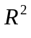and respectively), as well as, coefficients of determination for GLS models incorporating a single autoregressive term (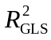).
 | OLS |  |  | GLS (AR1)
Factors (q)
S | Y U M (19) | 0.48 | 0.48 |  | 0.27
Y | S U M (10) | 0.13 | 0.13 |  | 0.18
M | S U Y (3) | 0.04 | 0.04 |  | 0.02
S ∩ Y | M | 0.01 | -0.02 |  | 0.25
S ∩ M | Y | 0.05 | 0.05 |  | 0.04
Y ∩ M | S | 0.08 | 0.07 |  | < 0.01
S ∩ Y ∩ M | -0.01 | -0.02 |  | < 0.01
Total (32) | 0.77 | 0.74 |  | 0.77

Table 2. The conditional explanatory power of several measured variables on species richness. The variables site, year, and management are as defined in Table 1. Note that the factors: site, year, and management consist of q explanatory variables. The model used to account for within site temporal autocorrelation in the residuals is displayed with the estimated range and nugget (See methods for details on the selection of the correlation model). Cells marked as “--” indicate that their values are identical to cells above. The standardized regression coefficient (β) is also given to indicate the strength and direction of the response of richness, as well as an estimate of variation explained, and conditional F-tests (approximate tests).
Explanatory Variables | Covariables | Temporal Autocorrelation Model  (range, nugget) | β |  | F-ratio | p-value
Factors (q)
site (19) | year + management | Gaussian  (3.92, 0.55) | NA | 0.25 | 5.80 | < 0.001
year (10) | site + management | -- | NA | 0.21 | 12.87 | < 0.001
management (3) | site + year | -- | NA | 0.01 | 4.07 | 0.008
Site Specific Variables
log Ca | slope + northness + year + management | Exponential  (10.91, 0.32) | -0.28 | 0.05 | 6.51 | 0.012
slope | log Ca+ northness + year + management | -- | -0.10 | < 0.01 | 0.71 | 0.400
northness | log Ca + slope + year + management | -- | 0.24 | 0.01 | 3.71 | 0.056
Year Specific Variables
summer rain | winter rain + spring rain + site + management | Exponential  (0.85)* | -0.19 | 0.03 | 26.65 | < 0.001
winter rain | summer rain + spring rain + site + management | -- | 0.15 | 0.02 | 15.47 | < 0.001
spring rain | summer rain + winter rain + site + management | -- | 0.14 | 0.01 | 11.43 | 0.001
Management Variables
years of bison | years since last burn + # of burns in 5 years + site + year | Gaussian  (3.92, 0.55) | 0.43 | 0.01 | 7.61 | 0.006
years since burn | years of bison + # of burns in 5 years + site + year | -- | -0.11 | < 0.01 | 3.52 | 0.062
# of burns in 5 years | years of bison + years since last burn + site + year | -- | -0.11 | < 0.01 | 1.34 | 0.249
*a one parameter model (i.e., the nugget was assumed to be zero)
Table 2. The results of Monte Carlo randomization tests using the results of pCCA under the reduced model. Each randomization test was conducted with 999 iterations. The variables site, year, and management are as defined in Table 1. Cells marked as “--” indicate that their values are identical to cells above.
Explanatory Variable | Covariables |  | Type of Randomization* | 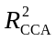 | 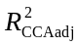 | F-ratio | p-value
Factors (q)
site (19) |  | year + management | random shuffle | 0.50 | 0.46 | 13.471 | 0.001
year (10) |  | site + management | toroidal shift | 0.04 | < 0.01 | 2.248 | 0.001
management (3) |  | site + year | random shuffle | 0.01 | < 0.01 | 2.145 | 0.001
-- |  | -- | toroidal shift | -- | -- | -- | 0.001
Site Specific Variables
log Ca | slope + northness + year + management |  | random shuffle | 0.13 | 0.12 | 19.735 | 0.001
slope | log Ca+ northness + year + management |  | random shuffle | 0.03 | 0.03 | 8.152 | 0.001
northness | log Ca + slope + year + management |  | random shuffle | 0.02 | 0.01 | 5.219 | 0.001
Management Variables
years of bison | years since last burn + # of burns in 5 years + site + year |  | random shuffle | < 0.01 | < 0.01 | 2.314 | 0.001
-- | -- |  | toroidal shift | -- | -- | -- | 0.001
years since burn | years of bison + # of burns in 5 years + site + year |  | random shuffle | < 0.01 | < 0.01 | 2.102 | 0.001
-- | -- |  | toroidal shift | -- | -- | -- | 0.001
# of burns in 5 years | years of bison + years since last burn + site + year |  | random shuffle | < 0.01 | < 0.01 | 1.616 | 0.001
-- | -- |  | toroidal shift | -- | -- | -- | 0.021
* random shuffle permutations were constrained to occur within a year, toroidal shifts were constrained within a given a site and preserved the temporal order of samples (see Methods for more explanation)
Figures
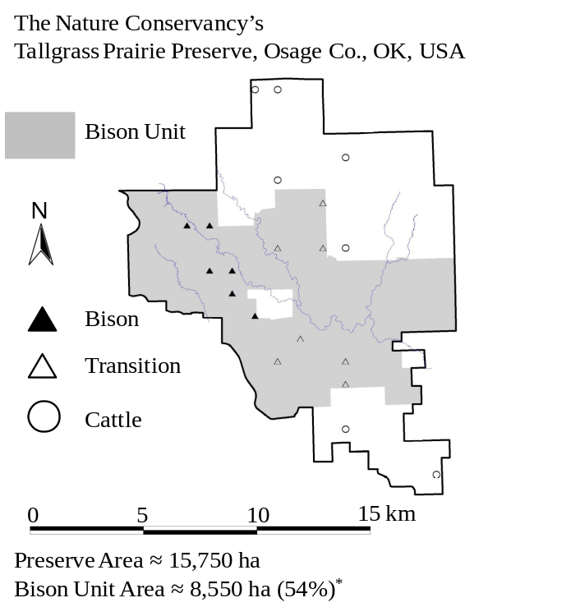
Fig. 1. A map of the Tallgrass Prairie Preserve. The shaded area denotes the bison unit which increased in area during the duration of the study. The twenty quadrats sampled each year of this study are displayed on the map. The sites that were bison at the beginning of the study (1998) are displayed with filled triangles (▲), those that transitioned during the study from cattle to bison are denoted by unfilled triangles (Δ), and the other cattle grazed samples are denoted by unfilled circles (○). *Area of bison unit is as of May 1, 2008.
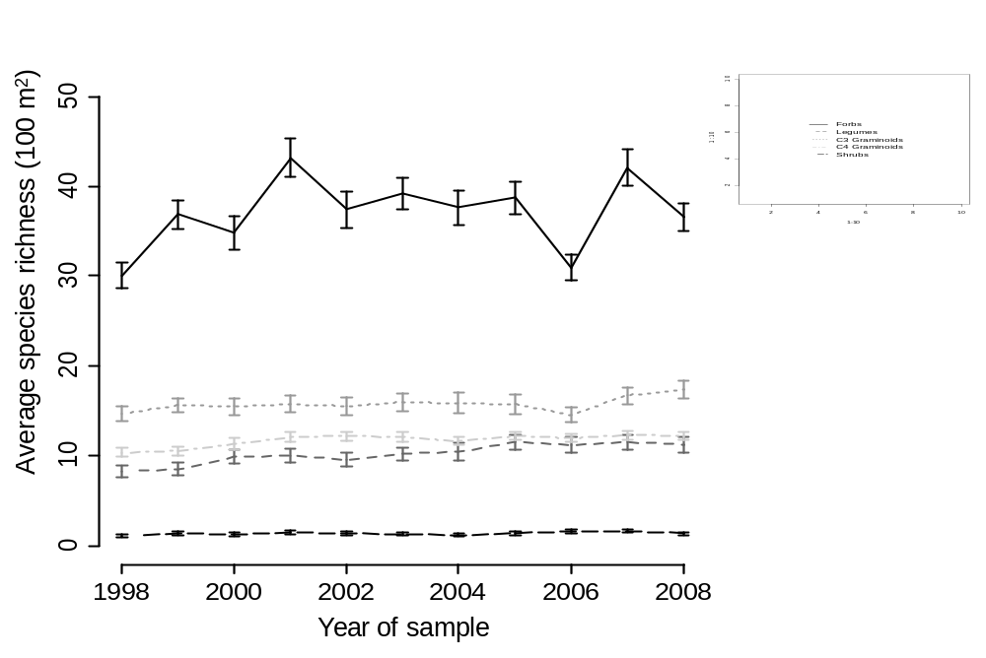
Fig 2. The average species richness of four functional groups: forbs (that are not legumes), legumes, C3 graminoids (grasses, sedges, and rushes), and C4 graminoids over the course of the study. The error bars display ± 1 standard error.
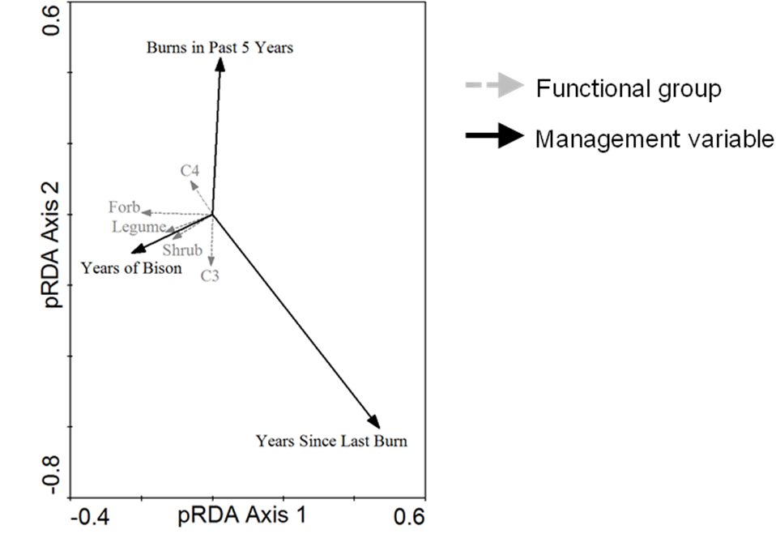
Fig. 4. A pRDA biplot of the richness of each functional group against the management variables after factoring out site and year effects. The management variables explained a significant amount of variance in the functional groups (R² = 0.12, 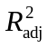= 0.10, F-ratio = 8.46, p-value = 0.001 after 999 torodial shifts within a site or random shifts within a year).
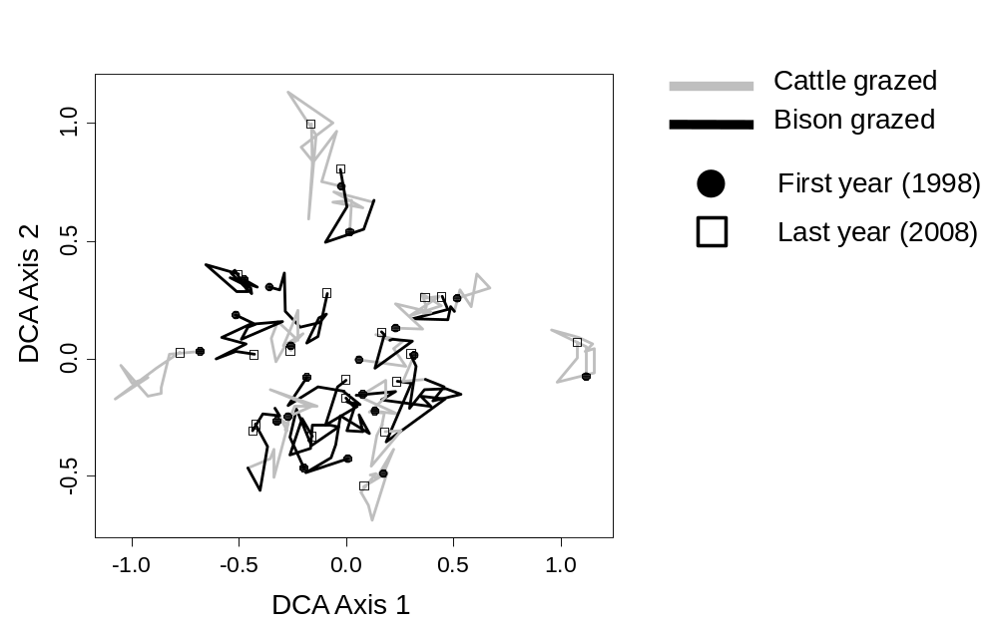
Fig. 5. DCA scatterplot (the eigenvalues were 0.152 and 0.108 for the first and second axis respectively) displaying the 20 quadrats from 1998 to 2008. The time series is indicated by a line segment (—) with joints at each year, a dark black line joins years in which the plot experienced bison grazing and a grey line demarcates years in which the plot experienced cattle grazing. The 1998 samples are indicated by circles (●) and the 2008 samples are indicated by squares (□).
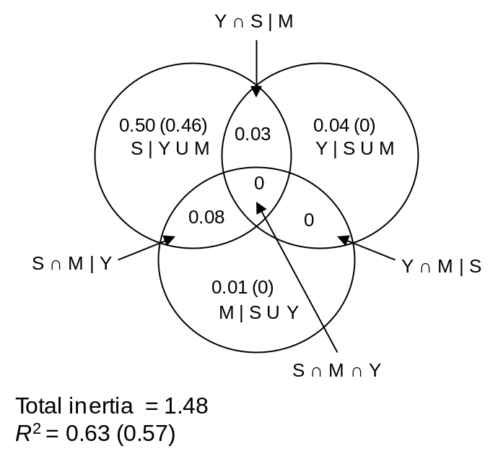
Fig. 6. A Venn diagram displaying the R² () of each fraction resulting from the variation partitioning of species composition using CCA. The three factors (classes of explanatory variables) were site (S), year (Y), and management (M). Note that R² in this context should not be interpreted as fraction of explained variance but rather fraction of explained inertia. For the shared fractions we only report the unbiased values.
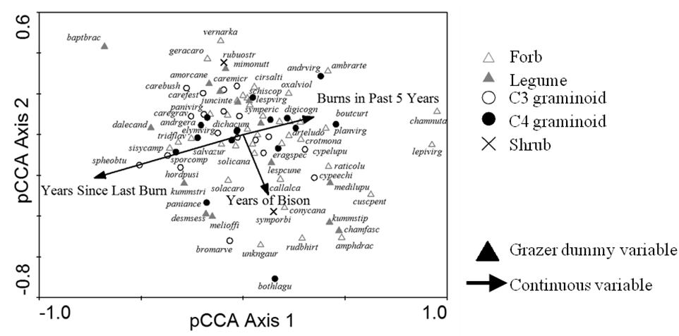
Fig. 7. A pCCA biplot displaying the influence of the management variables with the sites and years as covariables. The management variables in the model are indicated by black arrows. Only the 90 most abundant species of the 307 total are displayed for clarity. Abbreviations represent the first four letters of the genus and the first four of the letters
of the species (see Appendix C). The symbol of each species depends on which functional type it belongs to (see legend).
Appendix A. The correlation between each of the management variables and the correlation between various diversity indices.
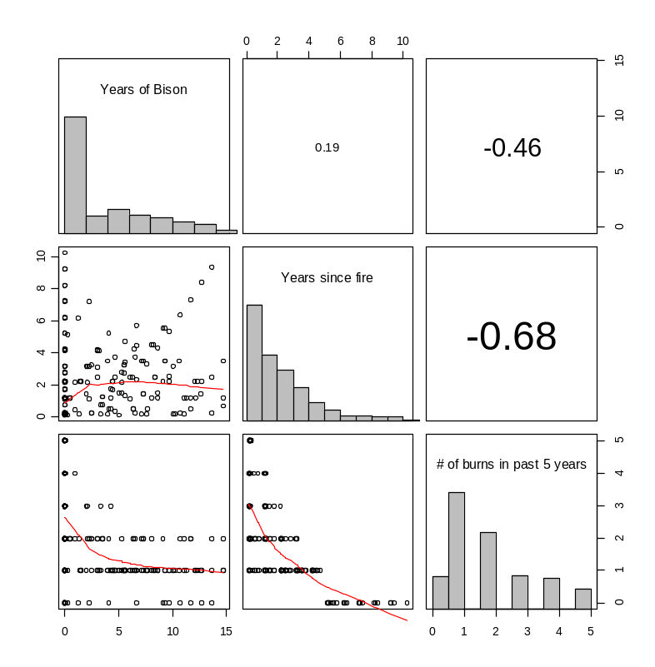
Figure A.1. Each management variable displaying a histogram of the number of observations of a given value over the entire course of the study. The magnitude and direction of the correlation of two variables is indicated by the cells in the upper triangle. The lower triangle indicates the scatterplot of the two variables. A lowess smoothing function was applied to the scatterplots to aid visual interpretation.
Appendix B. Isotropic variogram models for within site temporal autocorrelation of the residuals of the GLS models of species richness.

For each GLS model the single and double parameter formulations of five different models were compared using AIC which penalizes for the additional parameter.

Table B.1 The single parameter formulation of five isotropic variogram models. This table is recreated from Table 5.2 in Pinherio et al. (2008).
Model name | Single parameter formulation
Exponential | 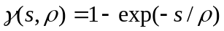
Gaussian | 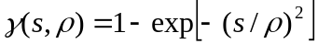
Linear | 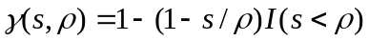
Rational quadratic | 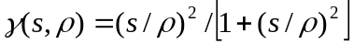
Spherical

In the table above, s is the distance between two observations (in our case number of years) and ρ is the range of the model or the distance at which observations are no longer correlated. The two parameter version of each model can be formulated simply by the addition of a third parameter, the nugget (c_{o}):
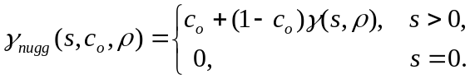
Appendix C. The relationship between richness and several other diversity indices examined in Wilsey et al. (2005).
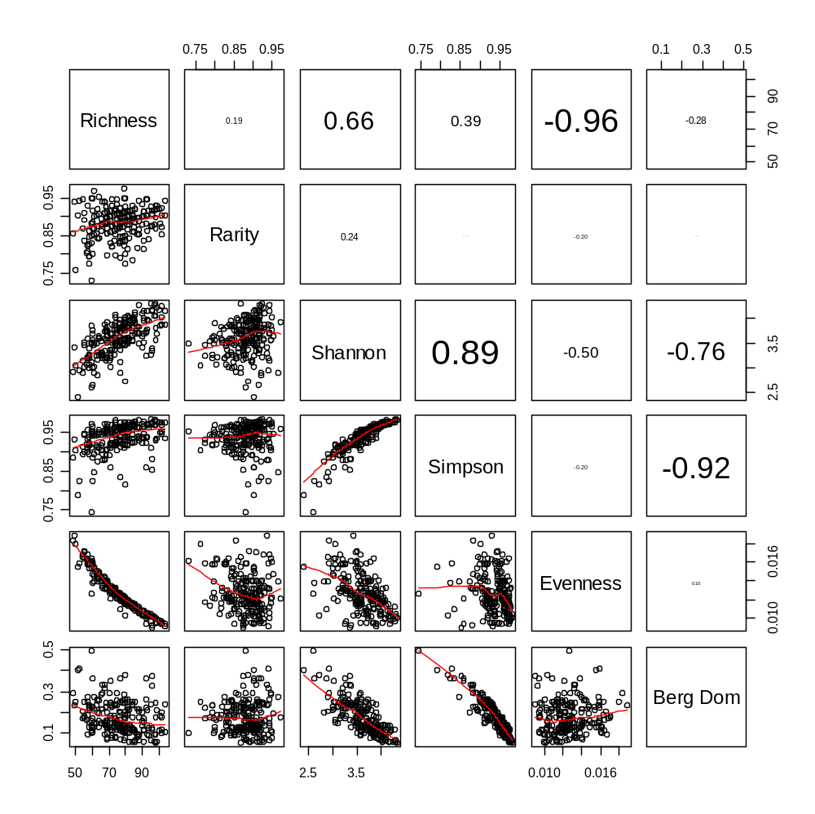
Figure A.2
Appendix C. The abbreviations for the species name in Fig. 6 the pCCA biplot of management effects. Only the 90 most abundant species were displayed sybmoically an of those only 59 names were displayed to decrease visual clutter
Table C.1. nomenclature follows the PLANTS database (USDA and NRCS 2008)
Abbreviated name | Binomial | Functional Group
ambrarte | Ambrosia artemisiifolia | F
amorcane | Amorpha canescens | L
amphdrac | Amphiachyris dracunculoides | F
andrgera | Andropogon gerardii | G4
andrvirg | Andropogon virginicus | G4
arteludo | Artemisia ludoviciana | F
baptbrac | Baptisia bracteata | L
bothlagu | Bothriochloa laguroides ssp. torreyana | G4
boutcurt | Bouteloua curtipendula | G4
bromarve | Bromus arvensis | G3
callalca | Callirhoe alcaeoides | F
carebush | Carex bushii | G3
carefest | Carex festucacea | G3
caregrav | Carex gravida | G3
caremicr | Carex microdonta | G3
chamfasc | Chamaecrista fasciculata | L
chamnuta | Chamaesyce nutans | F
cirsalti | Cirsium altissimum | F
conycana | Conyza canadensis | F
crotmona | Croton monanthogynus | F
cuscpent | Cuscuta pentagona | F
cypeechi | Cyperus echinatus | G3
cypelupu | Cyperus lupulinus | G3
dalecand | Dalea candida | L
desmsess | Desmodium sessilifolium | L
digicogn | Digitaria cognata | G4
elymvirg | Elymus virginicus | G3
eragspec | Eragrostis spectabilis | G4
geracaro | Geranium carolinianum | F
hordpusi | Hordeum pusillum | G3
kummstip | Kummerowia stipulacea | L
kummstri | Kummerowia striata | L
lepivirg | Lepidium virginicum | F
lespcune | Lespedeza cuneata | L
lespvirg | Lespedeza virginica | L
medilupu | Medicago lupulina | L
melioffi | Melilotus officinalis | L
mimonutt | Mimosa nuttallii | L
oxalviol | Oxalis violacea | F
paniance | Panicum anceps | G4
panivirg | Panicum virgatum | G4
planvirg | Plantago virginica | F
raticolu | Ratibida columnifera | F
rubuostr | Rubus ostryifolius | W
rudbhirt | Rudbeckia hirta | F
salvazur | Salvia azurea var. grandiflora | F
schiscop | Schizachyrium scoparium | G4
sisycamp | Sisyrinchium campestre | F
solacaro | Solanum carolinense | F
solicana | Solidago canadensis | F
spheobtu | Sphenopholis obtusata | G3
sporcomp | Sporobolus compositus | G4
symporbi | Symphoricarpos orbiculatus | W
symperic | Symphyotrichum ericoides | F
tridflav | Tridens flavus | G4
unkngaur | Gaura UNKOWN | F
vernarka | Vernonia arkansana | F
juncinte | Juncus interior | G3
dichacum | Dichanthelium acuminatum | G3

